Linear Algebra Thinking: Embodied, Symbolic and
Formal Aspects of Linear Independence
Sepideh Stewart | Michael O. J. Thomas
The University of Auckland | The University of Auckland
stewart@math.auckland.ac.nz | moj.thomas@auckland.ac.nz
Linear algebra is one of the first advanced mathematics courses that students encounter at university level. The transfer from a primarily procedural or algorithmic school approach to an abstract and formal presentation of concepts through concrete definitions, seems to be creating difficulty for many students who are barely coping with procedural aspects of the subject. In this study we have applied APOS theory, in conjunction to Tall’s three worlds of embodied, symbolic and formal mathematics, to create a framework in order to examine the learning of the linear algebra concept of linear independence by groups of second year university students. The results suggest that students with more representational diversity had more overall understanding of the concept. In particular the embodied introduction of the concept proved a valuable adjunct to their thinking.
Introduction
In recent years many mathematics education researchers have been concerned with students’ difficulties related to the undergraduate linear algebra courses. There is agreement that teaching and learning this course is a frustrating experience for both teachers and students, and despite all the efforts to improve the curriculum the learning of linear algebra remains challenging for many students (Hillel & Sierpinska, 1993; Dorier & Sierpinska, 2001). Students may cope with the procedural aspects of the course, solving linear systems and manipulating matrices, but struggle to understand the crucial conceptual ideas underpinning them. These definitions are considered to be fundamental as a starting point for concept formation and deductive reasoning in advanced mathematics (Vinner, 1991; Zaslavsky & Shir, 2005). Carlson (1997) expresses his concerns regarding the learning and teaching linear algebra as follows:
My students first learn how to solve systems of linear equations, and how to calculate products of matrices. These are easy for them. But when we get to subspaces, spanning, and linear independence, my students become confused and disoriented. It is as if a heavy fog has rolled in over them, and they cannot see where they are or where they are going. And I, as a teacher, become disheartened, and question my choice of profession. (p. 39)
Interestingly enough, at the end of the course many students do reasonably well in their final examinations, since the questions are mainly set on using techniques and following certain procedures, rather than understanding the concepts (Dorier, 1990). In other words, teachers may be placing an emphasis “less and less on the most formal part of the teaching (especially at the beginning) and most of the evaluation deals with the algorithmic tasks connected with the reduction of matrices of linear operators” (Dorier, et al., 2000, p. 28). This, as Sierpinska, et al. (2002, p. 2) describe it is a “waste of students’ intellectual possibilities”. They believe “linear algebra, with its axiomatic definitions of vector space and linear transformation, is a highly theoretical knowledge, and its learning cannot be reduced to practicing and mastering a set of computational procedures” (ibid, p. 1).
The action-process-object-schema (APOS) development in learning proposed by Dubinsky and others (e.g. Dubinsky & McDonald, 2001) suggests an approach different from the definition-theorem-proof that often characterises university courses. Instead mathematical concepts are described in terms of a genetic decomposition (GD–see e.g., Czarnocha, Loch, Prabhu, & Vidakovic, 2001) of their constituent actions, process and objects, presented in the order these could be experienced by the learner. For example, students should not be presented with the concept of linear independence if they do not understand scalar multiple and linear combination, since the concept of linear independence is constructed from these, each of which must be understood first. In recent years Tall has also introduced the idea of three worlds of mathematics, the embodied, symbolic and formal (Tall, 2004, 2007) that builds on APOS theory. The worlds describe a hierarchy of qualitatively different ways of thinking that individuals develop as new conceptions are compressed into more thinkable concepts (Tall & Mejia-Ramos, 2006). The embodied world, containing embodied objects (Gray & Tall, 2001), is where we think about the things around us in the physical world, and it “includes not only our mental perceptions of real-world objects, but also our internal conceptions that involve visuo-spatial imagery.” (Tall, 2004, p. 30). The symbolic world is the world of procepts, where actions, processes and their corresponding objects are realized and symbolized. The formal world of thinking comprises defined objects (Tall, Thomas, Davis, Gray, & Simpson, 2000), presented in terms of their properties, with new properties deduced from objects by formal proof. This theoretical position implies that students can benefit from constructing embodied notions underpinning concepts by performing actions that have physical manifestations, condensing these to processes and encapsulating these as objects in the embodied world, alongside working in the symbolic world and, finally, facing the formal world.
While it is relatively easy to present students with a matrix method for finding a set of linearly independent vectors, it seems that understanding the concept is much harder. This paper is concerned with student understanding of the concept of linear independence and how it is related to APOS theory and the representations of three worlds of mathematics.
Method
This research comprised a case study of two groups of second year students from Auckland University studying a general mathematics course that is one of the prerequisites for commerce and economics courses, and is recommended for students with a less strong mathematics background. It includes both advanced linear algebra (40%) and calculus (60%). Although, there was no intention to make strong claims about the two groups of students in this study, they were taught under different styles of teaching, one emphasising embodiment and linking of the concepts (Group A), and the other the definitions and matrices (Group B). The 16 students (Group A) who volunteered to participate in this study were the first author’s summer 2007 students.
The lectures for Group A were designed around the proposed framework (Figure 2) to give students the overall experience of the concepts in the embodied, symbolic and formal worlds of mathematics. For example, linear independence of vectors was presented by showing embodied, visual aspects of the concept first. This was then linked to the notion of linear combinations in the form of algebraic and matrix symbolisations. The formal definition was given only after the symbolic and visual aspects were addressed. At the end of the linear algebra lessons students were given a set of 14 questions on a variety of concepts in linear algebra, which was designed to examine their embodied, symbolic and formal understanding, rather than procedural abilities. In addition, 8 students from group A were interviewed. Group B consisted of 11 students who sat the same course in the previous semester with different lecturers. They were given the same test 4 days before their final examination. After the test the author offered Group B two tutorials on the central concepts of their linear algebra course (linear combinations, span, linear independence, and so on). The aim was to give students an explanation of these topics including elements of embodied, symbolic, and formal worlds. Two students from group B were interviewed after their examination.
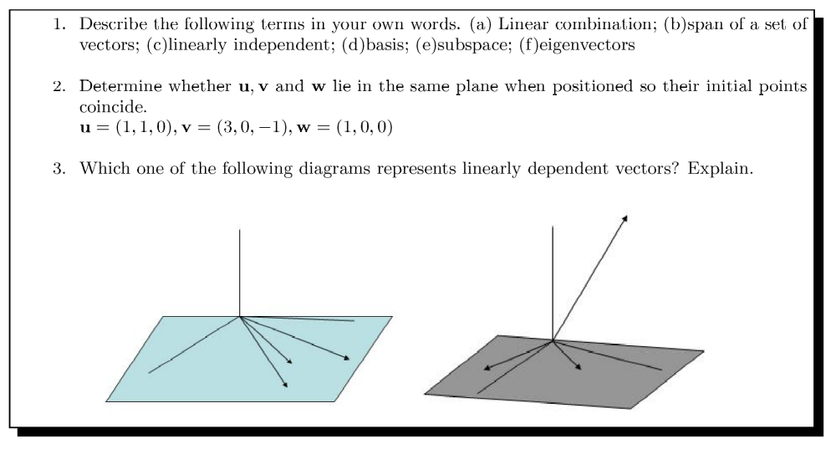
Figure 1. The questions used to investigate understanding of linear independence.

A possible genetic decomposition (GD) of the concept of linear independence suggested by applying APOS theory includes an action view where in the symbolic world independence or dependence is contingent on the ability to rearrange, say 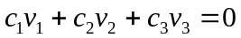 in IR³ to get a linear combination 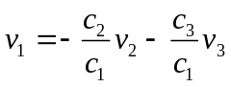 for specific vectors 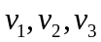, a process view that generalizes this action so that for linearly dependent vectors one vector can always be written as a linear combination, , of the others (i.e., the ability to see how to rearrange the above equation for any vector), and an object perspective of thinking of a set of n linearly independent vectors as an entity that can be used e.g., as a basis of a vector space or to form a span. Hence it is clear that these are dependant on a genetic decomposition of scalar multiple, linear combination, etc. However, instead of simply using the symbolic-algebra world we chose to apply the GD to each of Tall’s three worlds of mathematical thinking, and the resulting framework is shown in Figure 2.
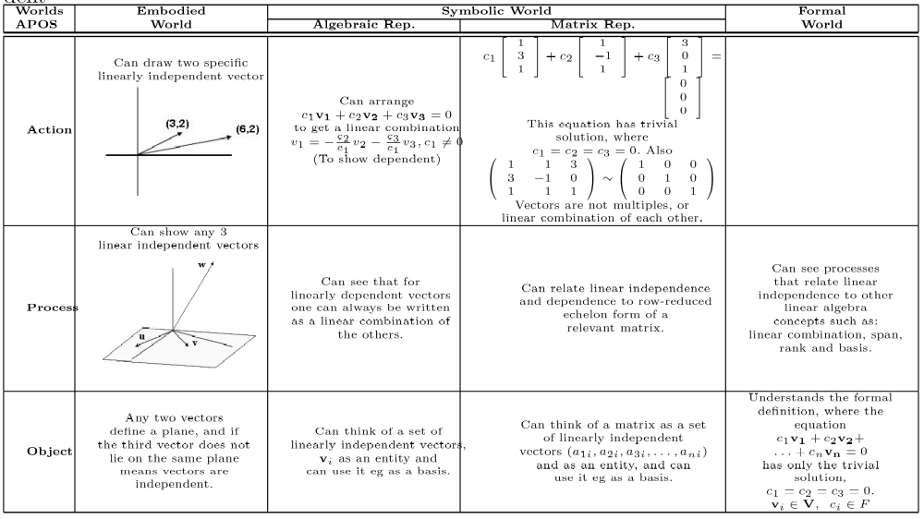
Figure 2. A framework for the concept of linear independence.
One of our hypotheses is that the embodied representations of the concept in IR ^{n} also provide students with valuable ideas to consider. These ideas include considering a set of non-zero vectors that do not lie on the same line (≥2 vectors) or plane/hyperplane (≥3 vectors). Thus if three vectors do not all lie on the same plane in IR³ they are linearly independent. In other words, since any two vectors define a plane through the set of all their linear combinations, if we have a third vector that does not lie on that plane then the vectors form a linearly independent set, which is also a geometrical object in this case. On the other hand, in the situation where, for example, three vectors do lie on the same plane the vectors are linearly dependent and each can be written as a linear combination of the other two. In addition it means that they cannot span the entire space IR³. The ability to form such connections between related concepts and their representations is necessary to enrich one’s linear independence schema and hence promote versatile thinking (Thomas, 2008). However, what often seems to happen in teaching is that the symbolic-matrix representation is favoured over others, and the primary activities (or actions) in this world involve putting vectors into a matrix and performing Gaussian elimination to try to reduce the matrix to the reduced row echelon form and reasoning from this in order to see whether or not the vectors are linearly independent.
Results
Defining linear independence
Of the 11 Group B students, five did not write anything when asked to define the term linear independence. Of the remaining six students no one referred to the definition symbolically. In contrast all 16 Group A students were able to write something for the term linear independence, and 7 (44%) students tried to link the term linear independence to the concept of linear combination. Some of the written comments from members of both groups are given in Table 1, along with a brief classification from the framework.
Table 1
A Comparison of Responses for the Definition of Linear Independence.
Student | Response type | Some written test responses
2B-3 | Embodied | Two or more vectors are not coincide or lie in the same plane
2B-2 | Symbolic, linear combination, linked to basis | Those vectors can’t be expressed in terms of other vectors. Those vectors are linearly independent. Every one is important to form the space”.
2B-7 | Symbolic, linear combination | When the set of vectors are not related or they are not a linear combination of each other
2B-8 | Symbolic, linear combination | A set of components e.g. vectors, functions that each one cannot be formed from any combination or multiples of the remaining components
2B-4 | Symbolic, linear combination | The components are not multiples of each other.
2B-11 | Symbolic, matrix process | Linearly independent would mean that a set of matrix has exactly the same number of rank and columns”.
2A-9 | Symbolic, linear combination | Vectors which are not multiple of each other, indeed none of them can be written as a linear combination of others.
2A-4 | Embodied | Vectors not collinear/on same plane.
2A-1 | Embodied | Non-parallel
2A-8 | Symbolic, definition related | Vectors in which there is no relationship between them i.e. the only way ax = 0 is if x = 0
2A-7 | Symbolic, definition related | If the vector v1, v2, . . . , vn forms the linear equation as c₁v₁+c₂v₂+. . .+ cnvn = 0 the equation has unique solution which is c₁ = c₂ = c₃ = 0. Then the vector[s] called linear independent.
2A-12 | Symbolic, definition related | ax₁ + bx₂ + cx₃ = 0, a = b = c = 0.
2A-5 | Symbolic, definition related | The only way to have a linear combination of a set of linearly independent vectors equal to zero is multiply them all by the scalar 0.
The results in Table 1 show that the Group A students were more likely to refer to the symbolic algebra definition of the term than the students from Group B, with three students using it to describe the meaning of the term. This may be because definitions were emphasised and linked to other concepts during the lectures and were included in their first assignment.
The main purpose behind Question 2 was to examine whether or not students had the ability to link the embodied phrase “lie in the same plane” to the concept of linear independence, and hence whether they could carry out a symbolic world action that tests for such independence in a specific case. Seven students from Group B and eight from Group A put the vectors into a matrix form and performed symbolic world Gaussian elimination, with some showing that the matrix reduced to the identity. Two students from Group B and eight from Group A went on to write that the vectors were linearly independent, confirming that they had made the correct link with the embodied idea. The working of one of these, 2B-3 is shown in Figure 3.
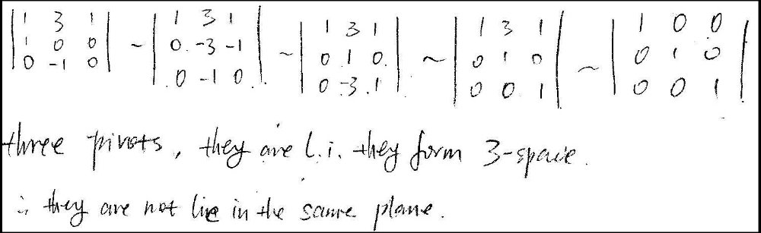
Figure 3. The working of 2B-3 showing a link between linear independence and lying in a plane.
However, five students (2A-1, 2A-2, 2A-3, 2A-9 and 2A-16) from Group A (the researcher’s students), approached the situation visually, with three students (2A-1, 2A-2, 2A-9) answering correctly and supporting their thinking with their own words (see Figure 4 for the work of two of the students). Both drew diagrams and used the fact that both vectors u and w had zeros for their z-components, and thus concluded that they must lie in the x−y plane, whereas vector v (having zero for its y-component) lies in the x−z plane. This shows strong embodied world thinking illustrated with diagrams and comprising a link to the symbolic-matrix (vector) representation.
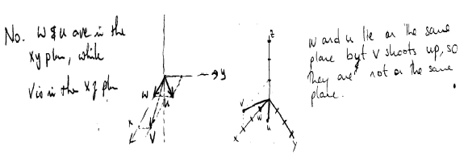
Figure 4. The working of 2A-1 and 2A-2 showing a link between linear independence and lying in a plane.
Question 3 (see Figure 1) presented two diagrams and asked which showed linearly independent vectors. Only four out of 11 Group B students were able to match the correct image to the concept of linear dependence confirming a lack of a link to a geometric perspective for a majority of these students. Of the remaining students, two did not respond and four were incorrect, with three of these reversing the embodied connection, stating for example that were dependent “As the vector do not lay on the same plane”. On the other hand, all 16 students in Group A were able to choose the correct diagram in response to this question, and showed an ability to justify their choice, with 75% employing the phrase “all the vectors are in the same plane”. This was not surprising, since the topic was introduced through embodied ideas, but it was encouraging to see that some of the ideas from the geometric representation remained.
Three case studies
For the definition student 2B-2 wrote: “Those vectors can’t be expressed in terms of other vectors. Those vectors are linearly independent. Every one is important to form the space” for his definition. Thus he was probably visualising a space and thinking that it is important for all the vectors to be there. He expressed a process-symbolic view, mentioning that “the vectors can’t be expressed in terms of other vectors”, and appeared to be thinking about span as he said “everyone is important to form a space”. In the second test he again gave a process view in the symbolic world as he wrote: “The vectors can’t express each other by addition and multiplication”, no doubt meaning a linear combination. In his interview, when he was asked what came to his mind first about the concept of linear independence, he said:
First thing those pictures of span. For example those three span in a 3 those span vectors formed this object and these 3, we need them to form this object, we can’t leave any of them. This I think it’s linearly independent because they can’t express one by others.
This confirmed that he was indeed thinking about span when he first said “every one is important to form a space”, and apparently this was the first thing that came to his mind. His use of the phrase “can’t express one by others” suggests that he was again referring to a linear combination, a concept that he had previously struggled to define or make sense of. The interview also confirmed that in the first test he was trying to visualize the vectors in the space and make some sense of them. When he was asked where he first saw those pictures, he replied:
Actually, I got this linearly independent idea from the class, I first got the definition. If those three cannot be add or scalar multiplication equal to each other, something from the definition. But when I was reading the textbook and I can’t quite sure to remember the definition. After that every time I see this kind of question I remembered the picture, it’s something like if we need to build a house we can’t leave the structure.
He expressed a process view again when he mentioned “if those three cannot be add or scalar multiplication equal to each other”. He also seemed to value having a picture of the concept in his mind, which every time he thought about the concept helped him to remember something about it. But again he acknowledges the fact that he cannot remember the definition. Somewhat surprisingly his linear algebra concept map (see Figure 5) was very basic, comprising only four items and referring to the definition as a procedural test for linear independence. It also failed to link span to basis. It seems that this student does use visual imagery to assist with his understanding but finds difficulty connecting the images to the processes that he is trying to learn to do the questions.
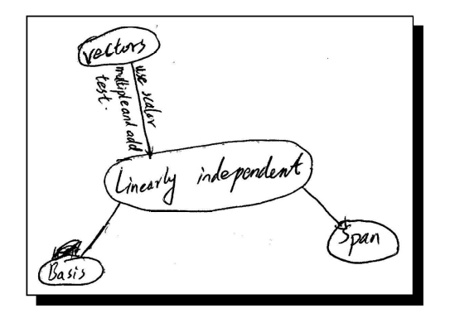
Figure 5. Student 2B-2’s linear algebra concept map.
In the test student 2C-4 wrote an embodied definition that “Vectors not collinear/on same plane”. Later, in his interview he described the term ‘linearly independent’ in the following manner: “Linearly independent, it means that it is not, in 2D is not parallel or not collinear and in 3D when you row reduce the matrix of 3 or 4 whatever it is not going to be a linear combination, it’s going to be a unique solution, or is not going to be a linear combination.” Thus while he initially employed embodied thinking with vectors in 2 or 3 dimensions he soon switched to the matrix representation, the predisposition of the course, and linked it to linear combination. When he was probed further and asked whether he would be more comfortable with symbols and matrices or with pictures, he replied: “I like the pictures as well, I like to see what is going on”. This showed that he most probably is appreciating and making use of a variety of representations, although geometry may not be at his forefront of thinking. His linear algebra concept map (see Figure 6) showed simple linear connections between the basic concepts, although he did use linear combination as a base and linked it to linear independence/dependence and span, but he did not link linear independence to span and basis. This student too tries to use imagery but also regresses to matrix processes for problems.
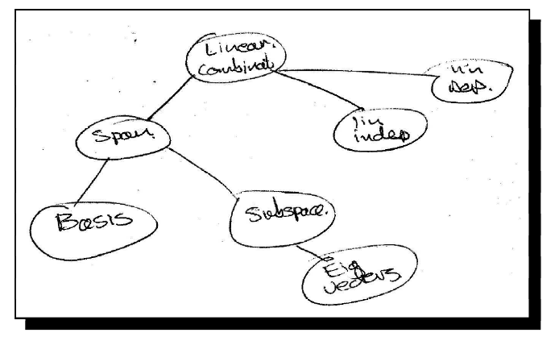
Figure 6. Student 2A-4’s linear algebra concept map.
Student 2C-8 wrote “Vectors in which there is no relationship between them i.e. the only way ax = 0 is if x = 0”, for her definition, but in an interview she described a wider view of the term in the following manner:
Linearly independent, when the vectors are not related in any way. Like if you take one vector and if they are dependent you take a vector you multiply it by a scalar, still the same vector in the same direction but different length, and if they are independent then they are in different direction, you can’t write linear combination.
Here she is thinking in an embodied manner (e.g. length and direction) about linear dependence and independence (hence the process-embodied cell of the framework), and is linking this thinking to linear combination and is not thinking in terms of procedures. When asked what was the first thing that came to her mind concerning the concept she said: “Relationship between the vectors. I, yeah, I always think of it as if they are dependent, then they are related. Like, yeah, because if you write them as a linear combination if they are dependent you find a relationship between the vectors, so if they are not related then they are independent.” This confirms the strong process-symbolic views in her thinking, as she links this concept to that of linear combination. However, from her previous comments it was clear that she was aware of the geometrical scenario as well. Surprisingly, although her linear algebra concept map contained quite a lot of detail she did not include anything about linear independence (see Figure 7).
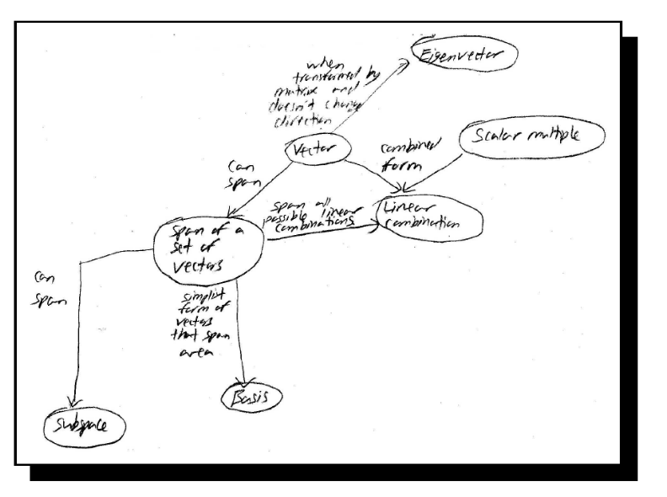
Figure 7. Student 2A-8’s linear algebra concept map.
Conclusion
This research confirms that some students struggle with both definitions and understanding of basic linear algebra concepts, such as linear independence. The results also reveal that different students prefer different modes of thinking, depending on which of the three worlds they favour and what actions they are performing. However, those whose thinking is primarily in the formal world, and who communicate knowledge of mathematics mainly through symbolic and formal thinking, also have the ability to recognise and employ embodied representations. The same is not true for the majority of students, who are thinking and working primarily in the symbolic world, especially when they are solving problems, since in this mode they often do not consider definitions. The evidence from our students is that many of these students have two compartments of knowledge. One for thinking about the ideas, which may include some embodied notions, and a separate schema for problem solving activity that is firmly based in the symbolic matrix world and often precludes any visual embodied thinking.
However, it seems, on the basis of the limited data collected in this study, that the use of embodied notions in the tutorials and lectures may have helped some of these students to enrich their thinking about linear algebra. Certainly the group A lecturer was confident that these students were “very comfortable moving from one representation to another, and could explain the links between formal and embodied notions.” This was confirmed by 2A-5’s comment that “Usually I go back to the definition first…all the scalars …to be zero…if two vectors are independent cannot be parallel and in R³ they can’t be on the same plane.” Here she links in one go both formal and embodied ideas. When asked how they felt about the value of visual, embodied representations, 2A-7 responded that “I usually use the picture but sometimes I just [work] from the calculations. Pictures are quite helpful but not like solving every question…If you draw it and point in the picture I think [it] is more clear.” 2B-3 was also very clear that a visual, embodied approach had greater value for her than beginning with definitions, and how she would explain some of the ideas to others, “…some graphs and also very clear explanation that helped me to understand…And if I become a tutor I teach as your way, first I...graph them, not the definition, I think its too difficult to understand, makes them confused.”
It has been suggested that a central goal of mathematics education should be to increase the power of students’ representations (Greer & Harel, 1998, Duval, 2006). We agree that this should encourage versatile thinking (Thomas, 2008) and think that adding a visual, embodied approach to teaching of linear algebra that is often based on symbolic and formal world thinking satisfies this goal. It should be noted though that these embodied notions must be linked to standard problem solving if they are to make a difference. We are continuing to construct and refine the framework, based on APOS theory and the three worlds of thinking, which presents possible embodied, symbolic and formal experiences that students could have with linear algebra concepts in the hope that it may assist with focussing teaching. Further research is under way to examine the value of the framework in learning other linear algebra concepts.
References
Carlson, D. (1997). Teaching linear algebra: Must the fog always roll in? In D. Carlson, C. R. Johnson, D. C. Lay, A. D. Porter, A. Watkins & W. Watkins (Eds.) Resources for teaching linear algebra (Vol. 42, pp. 39-51). MAA Notes. Washington: MAA.
Czarnocha, B., Loch, S., Prabhu, V., & Vidakovic, D. (2001). The concept of the definite integral: Coordination of two schemas. Proceedings of the 25th Annual Conference of the International Group for the Psychology of Mathematics Education (PME25), Vol. 2, 297-304, Utrecht: Freudenthal Institute.
Dorier, J.-L. (1990). Continuous analysis of one year of science students’ work, in linear algebra, in first year of French university, Proceedings of the 14th Annual Conference of the International Group for the Psychology of Mathematics Education, Mexico Vol. II., 35-42.
Dorier, J.-L., & Robert, A., & Robinet, J., & Rogalski, M. (2000). On a research programme concerning the teaching and learning of linear algebra in the first-year of a French science university, International Journal of Mathematical Education in Science and Technology, 31(1), 27-35.
Dorier, J.-L., & Sierpinska, A. (2001). Research into the teaching and learning of linear algebra, In D. Holton (Ed.) The teaching and learning of mathematics at university level: An ICMI study (pp. 255-273). Dordrecht, Netherlands: Kluwer Academic Publishers.
Dubinsky, E. & McDonald, M. (2001). APOS: A constructivist theory of learning. In D. Holton (Ed.) The Teaching and Learning of Mathematics at University Level: An ICMI Study (pp. 275–282). Dordrecht: Kluwer Academic Publishers.
Duval, R., (2006). A cognitive analysis of problems of comprehension in a learning of mathematics, Educational Studies in Mathematics, 61, 103-131.
Gray, E. & Tall, D. O. (2001). Relationships between embodied objects and symbolic procepts: An explanatory theory of success and failure in mathematics, In M. van den Heuvel-Panhuizen (Ed.) Proceedings of the 25th Conference of the International Group for the Psychology of Mathematics Education, Utrecht, Netherlands, 3, 65–72.
Greer, B. & Harel, G. (1998). The role of isomorphisms in mathematical cognition. Journal of Mathematical Behavior, 17(1), 5–24.
Hillel, J. & Sierpinska, A. (1993). On one persistent mistake in linear algebra, Proceedings of the 18th International Conference for the Psychology of Mathematics Education, Lisbon, Portugal, 3, 65-72.
Sierpinska, A., Nnadozie, A., & Okta, A. (2002). A study of relationships between theoretical thinking and high achievement in linear algebra. Concordia University: Manuscript.
Stewart, S. & Thomas, M. O. J., (2007a). Embodied, symbolic and formal aspects of basic linear algebra concepts, In J-H. Woo, H-C. Lew, K-S. Park, & D-Y. Seo (Eds.) Proceedings of the 30th Conference of the International Group for the Psychology of Mathematics Education, (Vol. 4, pp. 201-208). Seoul, Korea.
Stewart, S. & Thomas, M. O. J. (2007b). Embodied, symbolic and formal thinking in linear algebra. International Journal of Mathematical Education in Science and Technology, 38(7), 927-937.
Tall, D. O. (2004). Building theories: The three worlds of mathematics. For the Learning of Mathematics, 24(1), 29–32.
Tall D. O. (2007). Embodiment, symbolism and formalism in undergraduate mathematics education. Plenary paper at 10th Conference of the Special Interest Group of the Mathematical Association of America on Research in Undergraduate Mathematics Education, Feb 22–27, 2007, San Diego, California, USA. Available at http://cresmet.asu.edu/crume2007/eproc.html.
Tall, D. O. & Mejia-Ramos, J. P. (2006). The long-term cognitive development of different types of reasoning and proof, Conference on Explanation and Proof in Mathematics: Philosophical and Educational Perspectives, Essen, Germany.
Tall, D., Thomas, M. O. J., Davis, G., Gray, E. & Simpson, A. (2000). What is the object of the encapsulation of a process?, Journal of Mathematical Behavior, 18(2), 223–241.
Thomas, M. O. J. (2008). Developing versatility in mathematical thinking. Mediterranean Journal for Research in Mathematics Education, 7(2), 67-87.
Vinner, S. (1991). The role of definitions in the teaching and learning of mathematics. In D. O. Tall (Ed.), Advanced mathematical thinking (pp. 65–81). Dordrecht, The Netherlands: Kluwer Academic Publishers.
Zaslavsky, O. & Shir, K. (2005). Students’ conceptions of a mathematical definition. Journal for Research in Mathematics Education, 36(4), 317–346.

